# Problem 1.3

**What’s wrong with this comparison: Google’s net worth in 2017, about $700 billion, exceeds the GDP of many countries (e.g. Argentina’s 2016-GDP was about $550 billion).**

There are several problems with this comparison. First, the time periods from which data is being analyzed are different. The comparison uses Google’s net worth in 2017 and compares it with Argentina’s 2016 GDP. Therefore there is no definitive way to know if the claim that Google’s net worth exceeds Argentina’s GDP is still true, as Argentina’s GDP could have surpassed Google’s net worth in the years difference.

Second is the lack of examples. The comparison explicitly says that Google’s net worth exceeds the GDP of many countries while only providing one example of such a country. The world “many” is subjectively defined but implies “multiple.” One could argue that the comparison is therefore false because it only offers a single country with lower GDP. At the very least one could argue that the validity of the comparison is subjective as “many” can mean different things to different people.

Third is the fact that net worth and GDP are very different measurements. Net worth considers all the assets that a company holds. Unless the company does poorly and has to sell off some its assets, this number is expected to increase over time. GDP is a measurement of the value of all the goods that a country produces in a fiscal quarter. Every couple of months, GDP is “reset” to zero while, barring any unusual circumstances, a company’s net worth will not fluctuate all that much. The comparison is like saying oranges and bananas are different because they are different fruits – the statement Is technically true but it isn’t useful.

# Problem 2.5(b)

**Express the shaded region using unions, intersections, and complements.**

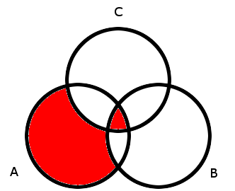

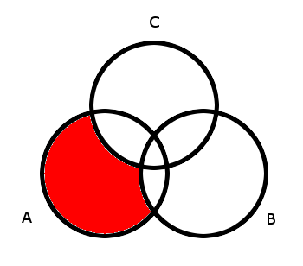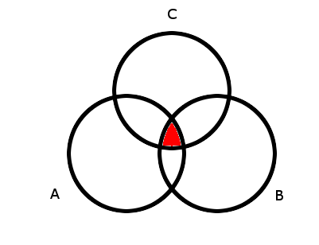The above shaded region is a union of the following shaded regions:

The smaller shaded region depicted on the left is simple to express – it is the intersection of all three circles. This is expressed as (A ꓵ (B ꓵ C)).

The larger shaded region depicted on the right consists of region A minus B and C. To convert this into the language of set operations, we’d say the shaded region is the intersection of A and the complement of B union C. This is expressed as A ꓵ .

Putting it all together, the final answer is the union of the two intersections and is expressed as this:

(A ꓵ (B ꓵ C)) ꓴ (A ꓵ )

# Problem 2.14

**Let A = {1,2,3} and B={a,b,c,d}. The Cartesian product A x B is the set of pairs formed from elements of A and elements of B.**

1. **List the elements in A x B. What is |A x B|?**

|  |  |  |  |  |
| --- | --- | --- | --- | --- |
|  | a | b | c | d |
| 1 | (1,a) | (1,b) | (1,c) | (1,d) |
| 2 | (2,a) | (2,b) | (2,c) | (2,d) |
| 3 | (3,a) | (3,b) | (3,c) | (3,d) |

Following the above table, the elements in A x B are: (1,a) (1,b) (1,c) (1,d) (2,a) (2,b) (2,c) (2,d) (3,a) (3,b), (3,c) and (3,d).

There are 3 * 4 = 12 elements, so |A x B| is 12.

1. **List the elements in B x A. What is |B x A|?**

|  |  |  |  |
| --- | --- | --- | --- |
|  | 1 | 2 | 3 |
| a | (a,1) | (a,2) | (a,3) |
| b | (b,1) | (b,2) | (b,3) |
| c | (c,1) | (c,2) | (c,3) |
| d | (d,1) | (d,2) | (d,3) |

Following the above table, the elements in B x A are: (a,1) (a,2) (a,3) (b,1) (b,2) (b,3) (c,1) (c,2) (c,3) (d,1) (d,2) and (d,3).

There are 3 * 4 = 12 elements, so |B x A| is 12.

1. **List the elements in A x A = A2. What is |A x A|?**

|  |  |  |  |
| --- | --- | --- | --- |
|  | 1 | 2 | 3 |
| 1 | (1,1) | (1,2) | (1,3) |
| 2 | (2,1) | (2,2) | (2,3) |
| 3 | (3,1) | (3,2) | (3,3) |

The elements are: (1,1) (1,2) (1,3) (2,1) (2,2) (2,3) (3,1) (3,2) (3,3).

3 x 3 = 9, so |A x A| = 9.

1. **List the elements in B x B = B2. What is |B x B|?**

|  |  |  |  |  |
| --- | --- | --- | --- | --- |
|  | a | b | c | d |
| a | (a,a) | (a,b) | (a,c) | (a,d) |
| b | (b,a) | (b,b) | (b,c) | (b,d) |
| c | (c,a) | (c,b) | (c,c) | (c,d) |
| d | (d,a) | (d,b) | (d,c) | (d,d) |

**Generalize the definition of A x B to a Cartesian product of three sets A x B x C.**

A x B x C = {(a, b, c) | a ∈ A, b ∈ B, c ∈ C}.

# Problem 3.33

**Compute the number of positive divisors of the following integers:**

**6, 8, 12, 15, 18, 30**

**4, 9, 16, 25, 36**

6 has 4 positive integer divisors: 1, 2, 3, and 6.

8 has 4 positive integer divisors: 1, 2, 4, and 8.

12 has 6 positive integer divisors: 1, 2, 3, 4, 6, and 12.

15 has 4 positive integer divisors: 1, 3, 5, and 15.

18 has 6 positive integer divisors: 1, 2, 3, 6, 9, and 18.

30 has 8 positive integer divisors: 1, 2, 3, 5, 6, 10, 15, and 30.

4 has 3 positive integer divisors: 1, 2, and 4.

9 has 3 positive integer divisors: 1,3, and 9.

16 has 5 positive integer divisors: 1, 2, 4, 8, and 16.

25 has 3 positive integer divisors: 1, 5, and 25.

36 has 9 positive integer divisors: 1, 2, 3, 4, 6, 9, 12, 18 and 36.

**Formulate a conjecture that relates a property of the number of divisors of n to a property of n. State your conjecture as a precise theorem (proof not needed).**

The first thing I noticed was that every integer will always be divisible by itself and 1. That means that 2 needs to be a constant in whatever formula I ended up using.

While listing all the divisors in the first part of the question, I found that a useful strategy consisted of focusing on the multiples of each number’s lowest prime factors.

For a number like 36, I found that the lowest prime factors were 2 and 3. From there I would check multiples of each prime factor and see if the multiples were valid divisors of the original number.

From there I noticed that every number could we written a product of its prime factor components. For example, 36 = 22*32 🡪 4 * 9 = 36.

I thought that the exponents of each prime factor might be important so I tried adding them. 2 + 2 = 4 though 36 has 9 divisors, so that couldn’t be correct. I tried multiplying them and got 2 * 2 = 4 again. However, I noticed that I added 1 to each exponent, to account for the fact that every number is divisible by itself and 1, the equation worked. (2+1)*(2+1) = (3*3) = 9.

This also works with other numbers in the list: 16 = 24*30 🡪 (4+1)(0+1) = (5*1) = 5 and 18 = 21*32 🡪 (1+1)(2+1) = (2*3) = 6.

Thus, my conjecture could be written as:

Where D(n) equals the number of divisors of a number n, D(n) = (a+1)(b+1)(c+1) … where n = xaybzc … and x,y, and z are all prime factors of n.

# Problem 3.34(a)-(c)

**For the Ebola spreading model, a square gets infected if at least two (non-diagonal) neighbors are infected.**

1. **Show the final state of the grid (Who is infected).**

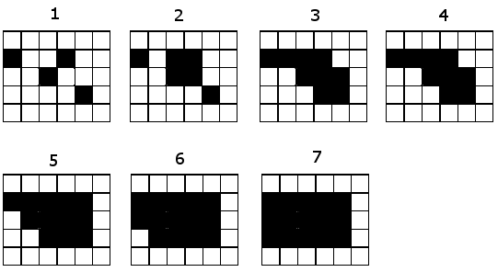

1. **Are there 5 initial infections that can infect the whole 6 x 6 square. What about with 6 initial infections? Also try the 4 x 4 and 5 x 5 grids.**
2. **For the n x n grid, n ∈ N, formulate a conjecture for the minimum number of initial infections required to infect the whole square.**

# Problem 1.2(f)

**On an 8 x 8 chess board, show that if you remove any two squares of different colors, you can tile the remainder of the board with dominos.**